Below is a table of student’s scores out of 100 on their Maths and English tests. Plot a   
      scatter graph from this data.

1. Provide appropriate label to co-ordinates and Title
2. Display description of graph in upper right  corner
3. Use different shapes and colors for representing marks of each subject

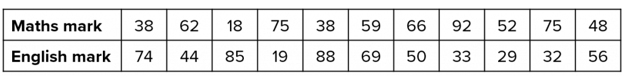

code

import matplotlib.pyplot as plt

import numpy as np

plt.title("student mark")

plt.xlabel("total mark")

plt.ylabel("mark obtained")

x = np.array([10,20,30,40,50,60,70,80,90,100])

x1 = [38,62,18,75,38,59,66,92,52,75]

plt.scatter(x,x1, color = 'red', marker="*")

y = [74,44,85,19,88,69,50,33,29,32]

plt.scatter(x,y, marker="^")

plt.legend(["Maths", "English"], loc ="upper right")

plt.show()

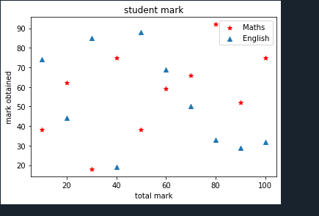

2.Write a Python program that accepts a 10 digit mobile number, and find the digits which are absent in a given mobile number

code

lst = []

p = int(input("Enter size of phonenumber : "))

print("enter the phonenumber")

# iterating till the range

for i in range(0, p):

ele = int(input())

lst.append(ele)

def absent_digits(lst):

all_nums = set([0,1,2,3,4,5,6,7,8,9])

lst = set([int(i) for i in lst])

lst = lst.symmetric_difference(all_nums)

lst = sorted(lst)

return lst

print("missing number")

print(absent_digits(lst))

